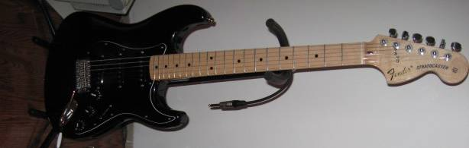
U.S. 70’s re-issue Strat, w/69 Fender pick-ups.
Vol = 6, Tone = 7+, Position = 1

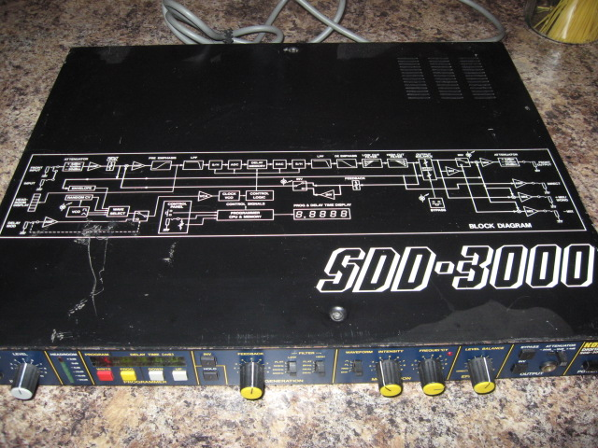
Korg SDD3000 (no delay)
Input = -30dB
Level = 7
Output = -10dB

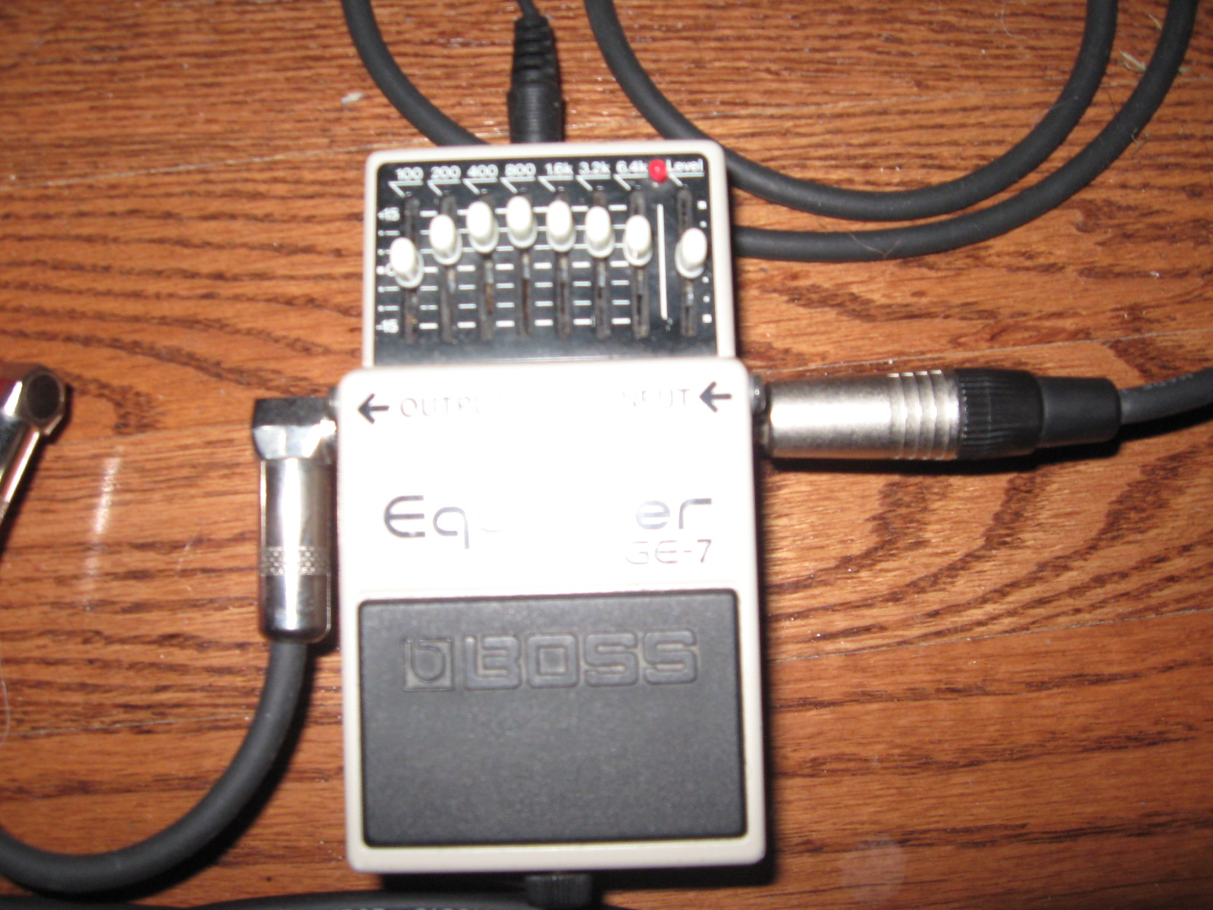
MIJ GE-7
See picture for slider positions

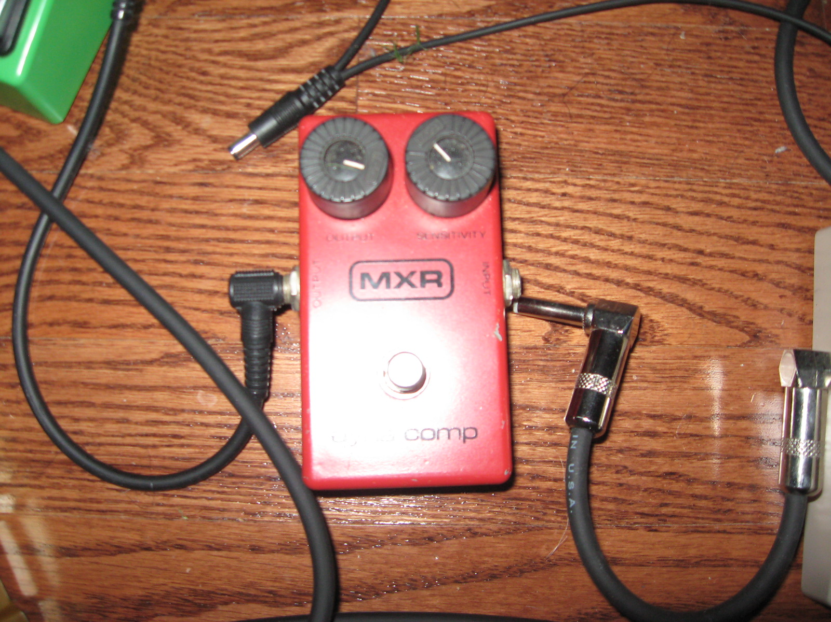
70’s Script Dynacomp
See picture for settings

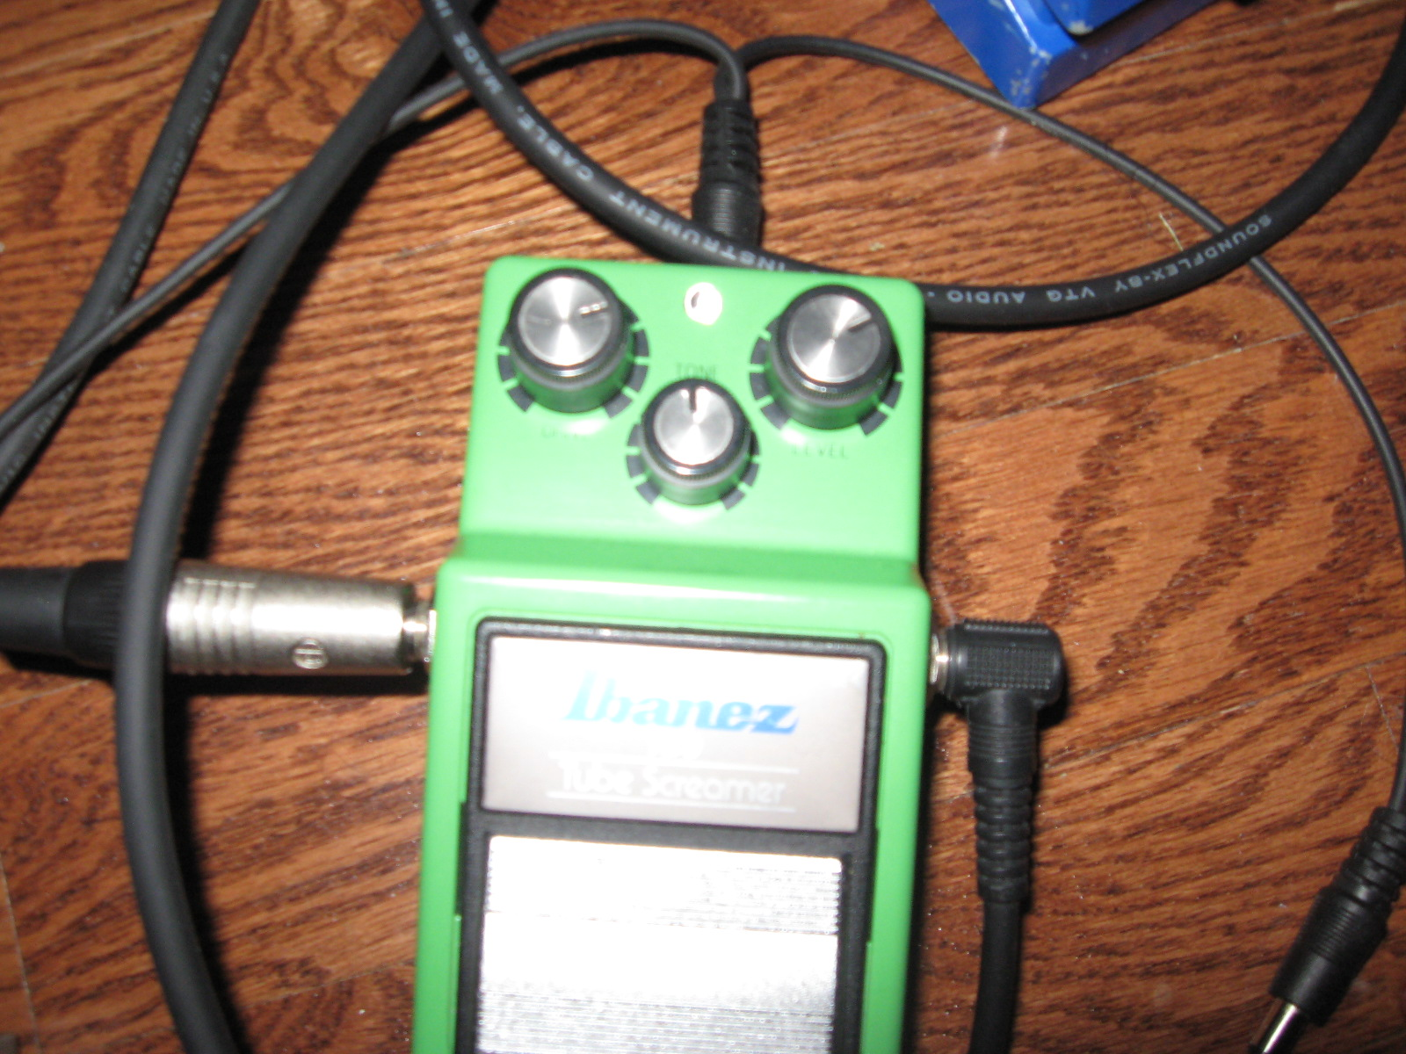
TS-9 Reissue, modded to TS-808 specifications
Drive = 2+ O’clock
Level = 2 O’clock
Tone = 12 O’clock


